**PYTHON PROGRAMMING USING SIMPLE STATEMENT AND EXPRESSION**

**EX : 2A PROGRAM FOR USING INTEGERS**

**DATE: 7.12.22**

**PROGRAM:**

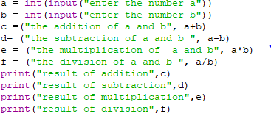

**OUTPUT:**

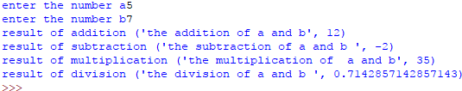

**EX: 2B**

**DATE: 7.12.22 DISPLAY THE COST OF APPLE**

**PROGRAM:**

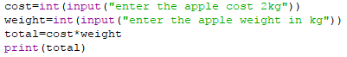

**OUTPUT:**

**cost of apple output.PNG**

**EX: 2C DISPLAY THE COST OF BOOKS**

**DATE: 7.12.22**

**PROGRAM:**

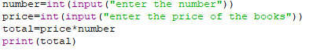

**OUTPUT:**

cost of book output.PNG

**EX: 2D FAHRENHEIT TO CELISIUS**

**DATE: 7.12.22**

**PROGRAM:**

temperature.PNG

**OUTPUT:**

**temperature output.PNG**

**EX: 2E CALCULATE THE SIMPLE INTEREST**

**DATE: 7.12.22**

**PROGRAM:**

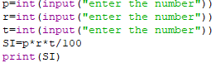

**OUTPUT:**

simple interest output.PNG

**EX: 2F SWAPPING THE VALUE (METHOD 1)**

**DATE: 7.12.22**

**PROGRAM:**

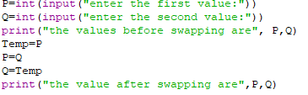

**OUTPUT:**

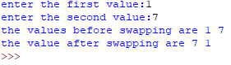

**EX: 2F SWAPPING OF THE VALUE (USING COMMA OPERATORS)**

**DATE: 7.12.22**

**PROGRAM:**

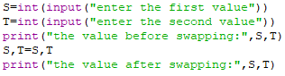

**OUTPUT:**

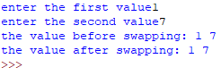

**EX: 2F SWAPPING OF THE VALUES (USING ARITHEMATIC OPERATORS**

**DATE: 7.12.22**

**PROGRAM:**

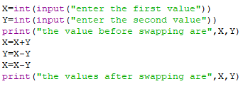

**OUTPUT:**

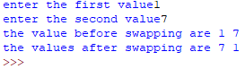

**EX: 2F SWAPPING OF THE VALUES USING XOR GATE OPERATORS**

**DATE: 7.12.22**

**PROGRAM:**

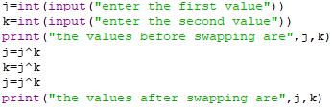

**OUTPUT:**

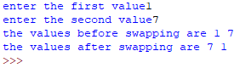

**EX: 2G CIRCULATES N VARIABLES (METHOD-1)**

**DATE: 7.12.22**

**PROGRAM:**

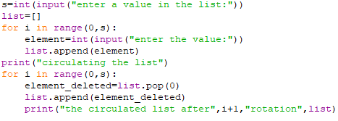

**OUTPUT:**

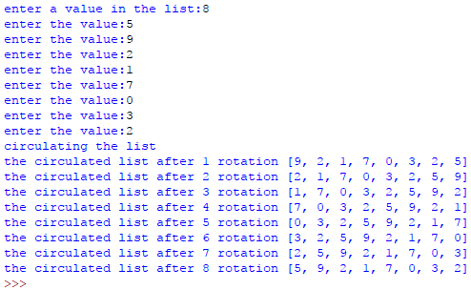

**EX: 2G CIRCULATE N VARIABLE (METHOD-2)**

**DATE: 7.12.22**

**PROGRAM:**

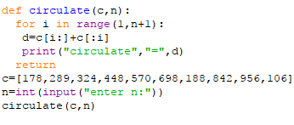

**OUTPUT:**

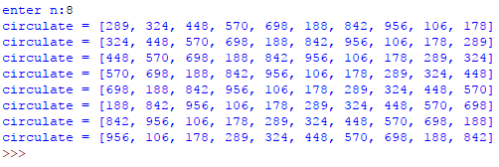

**EX: 2H DISTANCE BETWEEN TWO POINTS**

**DATE: 7.12.22**

**PROGRAM:**

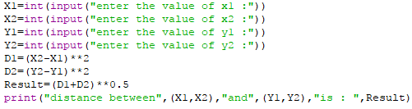

**OUTPUT:**

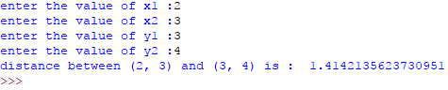

**EX: 2I FACTORIAL VALUE**

**DATE: 7.12.22**

**PROGRAM:**

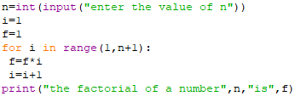

**OUTPUT:**

factorial value output.PNG

**EX: 2J EVEN NUMBER (OR) ODD NUMBER**

**DATE: 7.12.22**

**PROGRAM:**

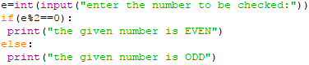

**OUTPUT:**

odd or even number output.PNG

**EX: 2K PRIME NUMBER OR NOT PRIME NUMBER**

**DATE: 7.12.22**

**PROGRAM:**

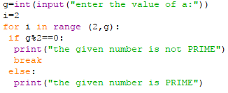

**OUTPUT:**

prime(or)not prime number output.PNG

**EX: 2L LEAP YEAR (OR) NOT LEAP YEAR**

**DATE: 7.12.22**

**PROGRAM:**

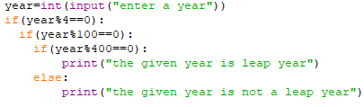

**OUTPUT:**

leap year output.PNG